25

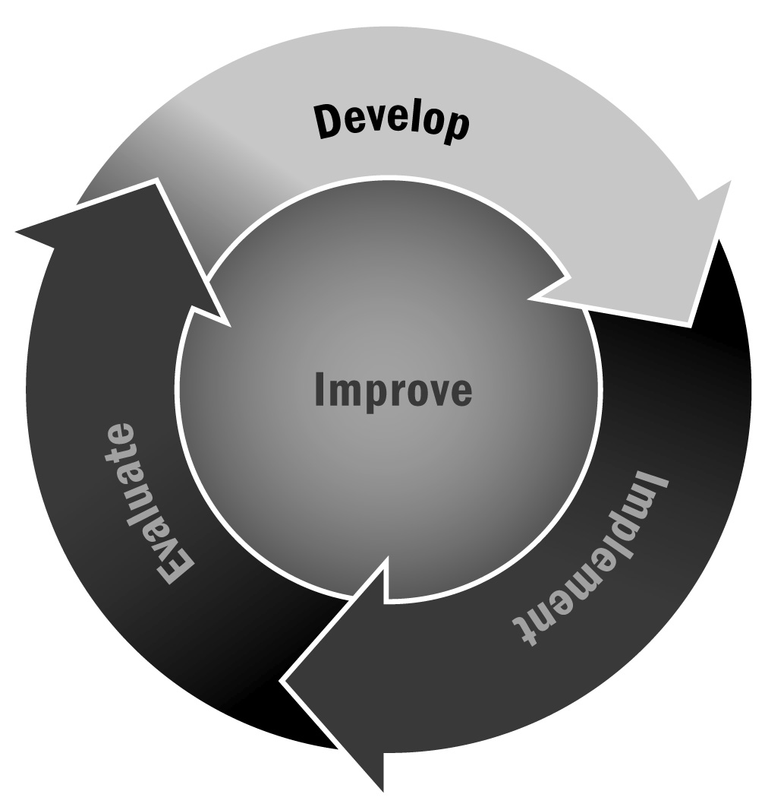
Developing as an Afterschool and Expanded Learning Professional
In Chapter 1, you learned that program staff members should not only have an opportunity to reflect on their own practices but also feel as though they have an opportunity to progress in their career. It is important to encourage staff members to reflect on their strengths and identify areas of growth that will help them in their career and contribute to the overall success of the program.
Directions: Read each action in the column on the left and then use the grid to determine where you are in your development as an afterschool and expanded learning professional. Highlight or mark that square for each action and work with your team or supervisor to develop a plan for ongoing professional development. Use these ratings when completing Tool 26—a self-assessment of effective qualities. Together, these two tools can help staff members identify a professional development plan.

Action | Beginning | Emerging | Applying | Integrating | Innovating
Reflecting on practice and planning professional development | Reflects on elements of youth learning (e.g., activities, relationships, skills, and interests) | Reflects on successes and dilemmas  Plans professional development to add to activities and youth engagement strategies | Reflects on the relationship between program offerings and youth learning  Plans professional development based on reflections | Analyzes and reflects on activities and learning based on evidence or data (grades, observations) gathered regularly | Integrates analysis and reflection into daily practice based on a wide variety of evidence and relationships with youth
Establishing professional goals and pursuing opportunities to grow professionally | Develops goals through required processes  Attends required meetings | Sets goals considering self-assessment and other feedback  Expands skills through professional development | Sets short-term professional goals based on self-assessment of effectiveness, youth learning, and feedback | Sets and modifies short-and long-term goals considering self-assessment and feedback | Contributes to professional organizations, literature, and development  Leads professional development
Working with communities to improve your practice | Learns about the young people’s communities  May take youth into community as part of activities or projects | Increases understanding of the roles of the community in young people’s lives  Attends community events | Identifies needs and resources  Expands knowledge of connections to community | Uses knowledge of the community to strengthen connections with the local community, culture, services, and resources to aid the program | Promotes program and community collaboration with advisory group  Provides youth with a wide range of community activities and service projects
Balancing professional responsibilities and maintaining motivation | Has a positive attitude with youth  Has a basic understanding of professional responsibilities | Maintains a positive attitude, demonstrates understanding of professional responsibilities, and seeks support to balance responsibilities | Maintains a positive attitude through the year, demonstrates professional integrity, and balances responsibility with personal needs | Maintains motivation and a commitment to all youth; demonstrates professional integrity | Maintains motivation and models commitment to all youth, school, staff, and community

